Assignment -1

1. Explain the difference between frontend, backend, and full-stack development with suitable real-world examples.
Frontend | Backend | Full-Stack
Frontend is the part of a website that users can see and interact with. | Backend is the server-side part that processes requests and manages data. | Full-stack development includes both frontend and backend.
Technologies: HTML, CSS, JavaScript | Technologies: Node.js, PHP, Java, Python | Uses both frontend and backend technologies.
Example: Login page, buttons, images. | Example: Checking login details from the database. | Example: A developer builds the complete Amazon website.

2. Create a simple diagram showing how the client-server model works in web architecture.
+-----------+ HTTP Request +-------------+
| Client | -----------------------------> | Web Server |
| (Browser) | | |
+-----------+ <----------------------------- +-------------+
HTML/CSS/JS Response

3. Describe how a browser requests and displays a web page from a web server.
- The user enters a website URL in the browser.
- The browser sends an HTTP request to the web server.
- The web server processes the request.
- The server sends HTML, CSS, JavaScript, and other files.
- The browser renders these files and displays the webpage.

4. Identify and list the tools required to set up a web development environment. Explain the purpose of each.
Tool | Purpose
Visual Studio Code | Code editor for writing HTML, CSS, and JavaScript.
Google Chrome | Testing and viewing web pages.
Live Server Extension | Automatically refreshes the webpage after changes.
Git | Version control to track code changes.
GitHub | Stores and shares code online.

5. Explain what a web server is and give examples of commonly used servers.
A web server is software that stores website files and sends them to users when requested.
Examples:
- Apache HTTP Server
- Nginx
- Microsoft IIS
- LiteSpeed
- Node.js Server (Express)

6. Define the roles of a frontend developer, backend developer, and database administrator in a project.

Frontend Developer
- Designs the user interface.
- Uses HTML, CSS, and JavaScript.

Backend Developer
- Develops server-side logic.
- Connects the application with the database.

Database Administrator (DBA)
- Creates and manages databases.
- Ensures data security and backup.

7. Install VS Code and configure it for HTML, CSS, and JavaScript development. Take a screenshot of the setup.

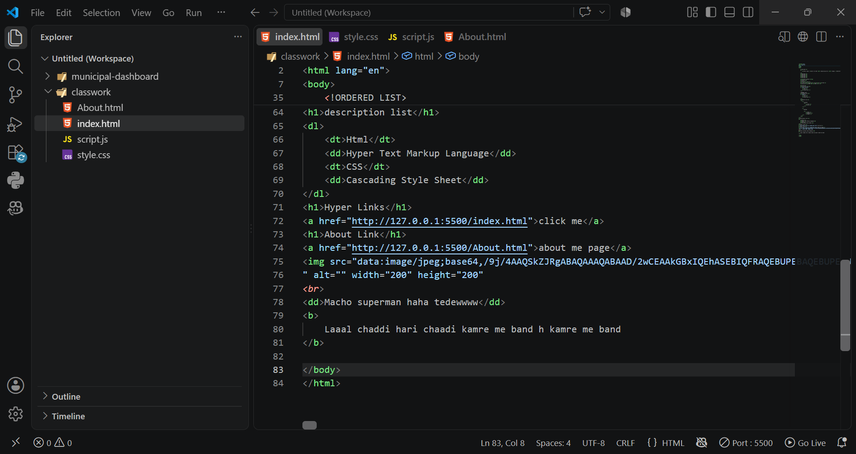

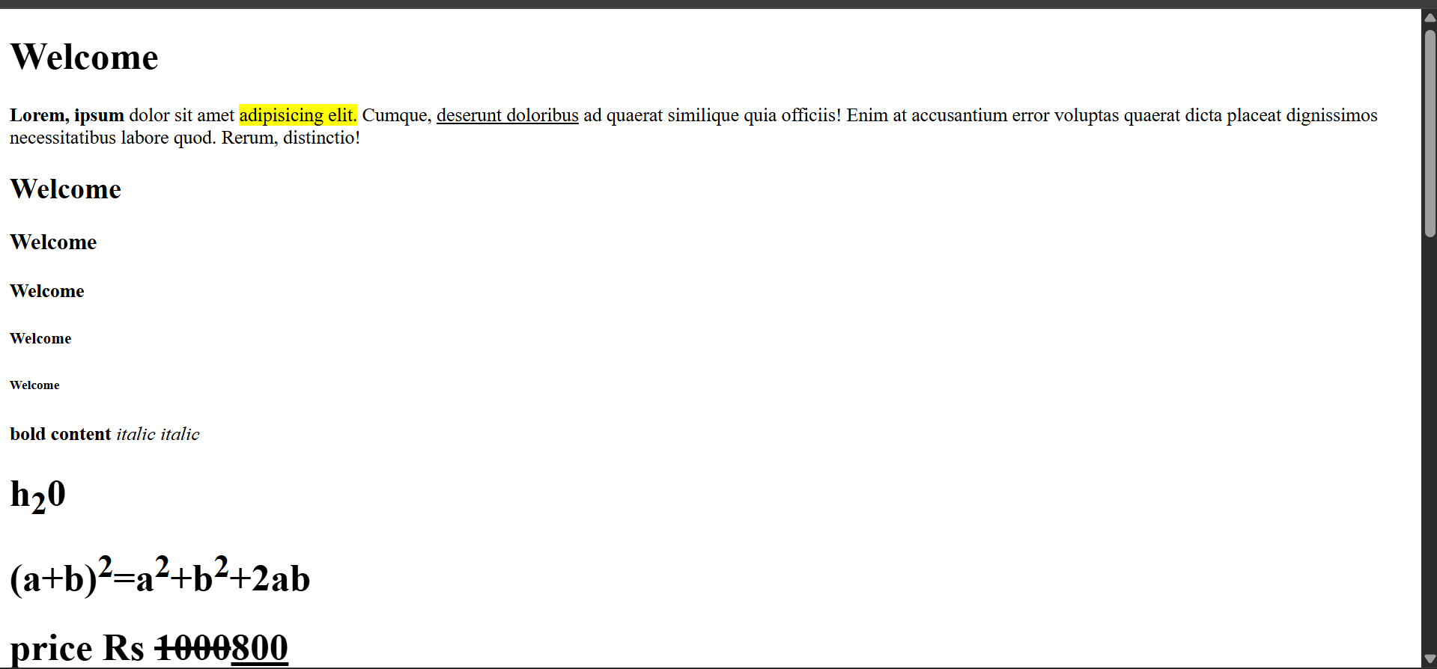

8. Explain the difference between static and dynamic websites. Provide an example of each.
Static Website | Dynamic Website
Shows fixed content. | Content changes based on user or database.
Faster and simpler. | More interactive.
Uses HTML and CSS only. | Uses HTML, CSS, JavaScript, and backend technologies.
Example: Portfolio website | Example: Facebook, Amazon

9. Research and list five web browsers. Explain how rendering engines differ between them.
Browser | Rendering Engine
Google Chrome | Blink
Microsoft Edge | Blink
Mozilla Firefox | Gecko
Apple Safari | WebKit
Opera | Blink

Difference:
A rendering engine converts HTML, CSS, and JavaScript into the webpage you see. Different engines may display the same webpage slightly differently and have different performance characteristics.

10. Draw a labeled diagram showing the basic web architecture flow — client, server, database.
+---------+
| Client |
| Browser |
+---------+
|
HTTP Request
|
v
+--------------+
| Web Server |
+--------------+
|
Database Query
|
v
+--------------+
| Database |
+--------------+
|
Data Returned
|
v
+--------------+
| Web Server |
+--------------+
|
HTTP Response
|
v
+---------+
| Client |
| Browser |
+---------+

